1 Kings 18

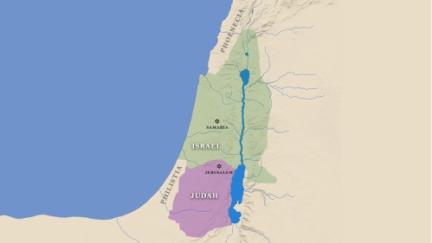

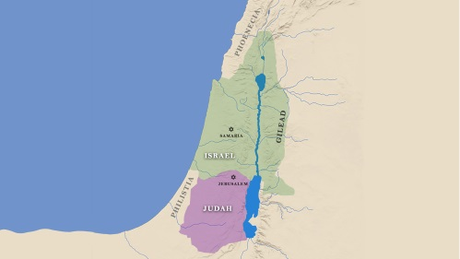

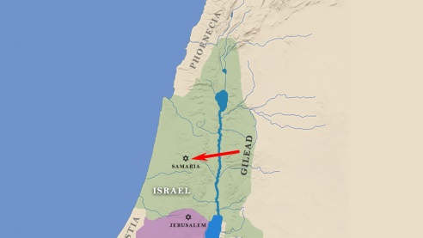

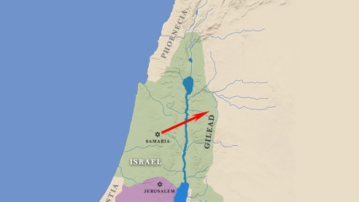

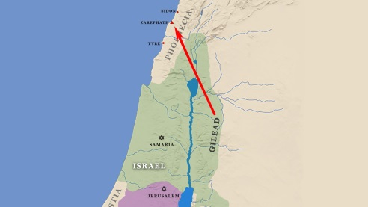

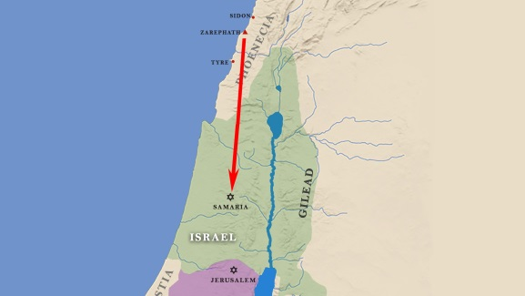

. . . the days of Elijah, when the heavens were shut up three years and six months . . . Luke 4:25

Elijah . . . prayed fervently that it might not rain, and for three years and six months it did not rain on the earth. James 5:17

[CAN WE FIT THE 2 VERSES ABOVE ALL ON ONE SLIDE? I CAN PROVIDE JPEG IF SYSTEM WON’T ALLOW FOR THAT]

When Ahab saw Elijah, Ahab said to him, “Is it you, you troubler of Israel?” And he answered, “I have not troubled Israel, but you have, and your father’s house, because you have abandoned the commandments of the Lord and followed the Baals.
1 Kings 18:17-18

Take care lest your heart be deceived, and you turn aside and serve other gods and worship them; then the anger of the Lord will be kindled against you, and he will shut up the heavens, so that there will be no rain, and the land will yield no fruit, and you will perish quickly off the good land that the Lord is giving you.
Deuteronomy 11:16-17

Now therefore send and gather all Israel to me at Mount Carmel, and the 450 prophets of Baal and the 400 prophets of Asherah, who eat at Jezebel’s table.” So Ahab sent to all the people of Israel and gathered the prophets together at Mount Carmel.
1 Kings 18:19-20

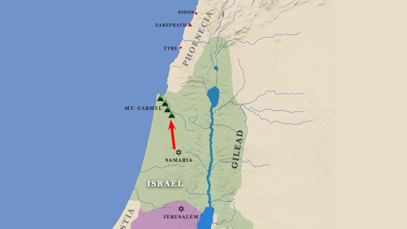

And Elijah came near to all the people and said, “How long will you go limping between two different opinions? If the Lord is God, follow him; but if Baal, then follow him.” And the people did not answer him a word.
1 Kings 18:21-25

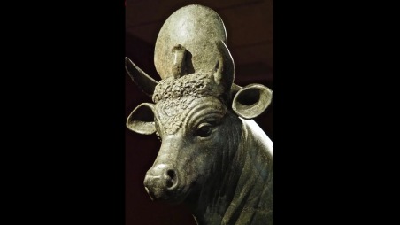

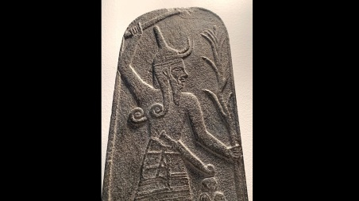

Then Elijah said to all the people, “Come near to me.” And all the people came near to him. And he repaired the altar of the Lord that had been thrown down. Elijah took twelve stones, according to the number of the tribes of the sons of Jacob, to whom the word of the Lord came, saying, “Israel shall be your name,” and with the stones he built an altar in the name of the Lord. And he made a trench about the altar, as great as would contain two seahs of seed. And he put the wood in order and cut the bull in pieces and laid it on the wood. And he said, “Fill four jars with water and pour it on the burnt offering and on the wood.” And he said, “Do it a second time.” And they did it a second time. And he said, “Do it a third time.” And they did it a third time. And the water ran around the altar and filled the trench also with water.
And at the time of the offering of the oblation, Elijah the prophet came near and said, “O Lord, God of Abraham, Isaac, and Israel, let it be known this day that you are God in Israel, and that I am your servant, and that I have done all these things at your word. Answer me, O Lord, answer me, that this people may know that you, O Lord, are God, and that you have turned their hearts back.” Then the fire of the Lord fell and consumed the burnt offering and the wood and the stones and the dust, and licked up the water that was in the trench.
1 Kings 18:30-38

And when all the people saw it, they fell on their faces and said, “The Lord, he is God; the Lord, he is God.”
1 Kings 18:39

And Elijah said to them, “Seize the prophets of Baal; let not one of them escape.” And they seized them. And Elijah brought them down to the brook Kishon and slaughtered them there. 1 Kings 18:40

The river Kishon swept them away,
the age-old river, the river Kishon.
March on, my soul; be strong!
Judges 5:12

