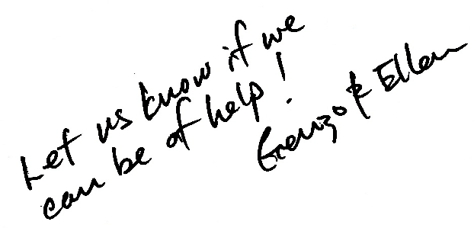

**Hello Neighbor!**

We know this can be a challenging time for many people. We have appreciated living in this neighborhood – and you are valuable to us as part of our community.

We’re your neighbors and we wanted to check to make sure you’re doing all right. If there’s any way we can come alongside to help you, please let us know – we want to help!

Do you need help with–

• picking up groceries • urgent supplies

• a friendly call • prayer

• a sewn mask • something else?

If we can’t help you, we are members of a local church (Community Fellowship) that may be able to further assist you.

We are [CHANGE THIS:] Your address, 1234 Highland Avenue; [your.name@gmail.com](mailto:your.name@gmail.com); 123-456-7890.

Let us know!

(Given the current situation, we will take every precaution to ensure we’re only spreading kindness! We will seek to avoid physical contact, wash hands, and leave any items on your doorstep!)

[erase this and write in your own line]

**Hello Neighbor!**

We know this can be a challenging time for many people. We have appreciated living in this neighborhood – and you are valuable to us as part of our community.

We’re your neighbors and we wanted to check to make sure you’re doing all right. If there’s any way we can come alongside to help you, please let us know – we want to help!

Do you need help with–

• picking up groceries • urgent supplies

• a friendly call • prayer

• a sewn mask • something else?

If we can’t help you, we are members of a local church (Community Fellowship) that may be able to further assist you.

We are [CHANGE THIS:] Your address, 1234 Highland Avenue; [your.name@gmail.com](mailto:your.name@gmail.com); 123-456-7890.

Let us know!

(Given the current situation, we will take every precaution to ensure we’re only spreading kindness! We will seek to avoid physical contact, wash hands, and leave any items on your doorstep!)

[erase this and write in your own line]