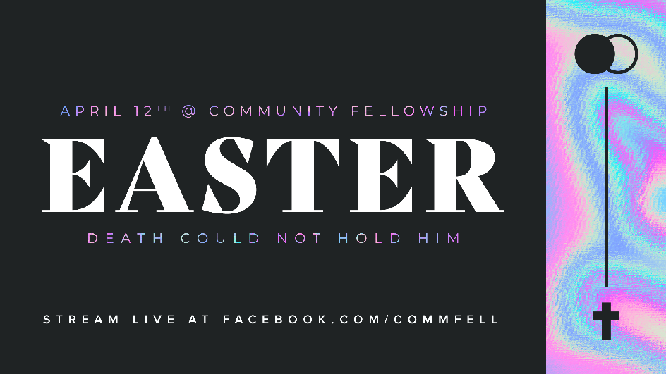

April 8, 2020
Dear CF Family,
The COVID-19 crisis presents a unique opportunity to share the good news of Jesus with people who are looking for hope in a fearful world.
Ed Stetzer recently commented, “this week may be the most receptive time EVER to share the gospel. As our deeds of service & words of invitation are both evident, we can engage whole communities with the gospel this week!”
I recently came across a simple challenge for Christians to use social media to testify to the transforming grace of our Lord. The challenge is to record a 1-2 minute video sharing your testimony of how Jesus changed your life and post it with the hash tag #JesusChangedMyLife and also tag our church’s social-media handle in the post (@commfell). If you prefer, you could write a short testimony in a social-media post or an email to family and friends.
If friends and followers respond to your post with comments or questions you might consider sharing a link to our Easter celebration service (facebook.com/commfell) this Sunday to find out more about who Jesus is and what it means to be His disciple! Feel free to share the graphic at the top of this letter as your personal invitation to the CF Easter Sunday live-stream service. (See instructions below)
I hope many of us will take this challenge and I hope all of us will pray that God will use these efforts for His glory.
Faithfully,
Pastor Will

How to Share the Easter Graphic:

Windows 10 - left click on the Easter image above. Once the image is selected, right click to copy or save picture as a file that you can share with others.

Mac - hold control and click on the Easter image above. Choose to copy or share via email or other application.

iOS - touch and hold your finger on the Easter image above. Share, Add to Photos or Copy.

