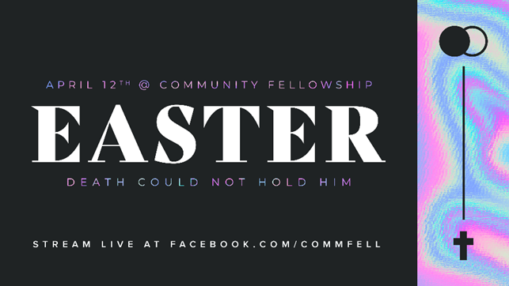

April 8, 2020
Dear CF Family,
The COVID-19 crisis presents a unique opportunity to share the good news of Jesus with people who are looking for hope in a fearful world.
Ed Stetzer recently commented, “this week may be the most receptive time EVER to share the gospel. As our deeds of service & words of invitation are both evident, we can engage whole communities with the gospel this week!”
I recently came across a simple challenge for Christians to use social media to testify to the transforming grace of our Lord. The challenge is to record a 1-2 minute video sharing your testimony of how Jesus changed your life and post it with the hash tag #JesusChangedMyLife and also tag our church’s social-media handle in the post (@commfell). If you prefer, you could write a short testimony in a social-media post or an email to family and friends.
If friends and followers respond to your post with comments or questions you might consider sharing a link to our Easter celebration service (facebook.com/commfell) this Sunday to find out more about who Jesus is and what it means to be His disciple!
I hope many of us will take this challenge and I hope all of us will pray that God will use these efforts for His glory.
Faithfully,
Pastor Will

